Supplementary Material

Section 1. Life Cycle Inventory–Innovative product system
Table 1–4 reports the S-LCA inventory of SHDB processes used to model the life cycle of the baking tray covered with the innovative coating: raw material sourcing and production, use and maintenance for the whole five year life cycle, including nine re-application of the coating.
Table S1. Raw materials to produce the innovative coating.
Type | Element | SHDB
Material | SiC (60 nm) | Mineral products nec/CHN S
Material | SiC (500 nm) | Mineral products nec/CHN S
Material | TiO2 shell precursor | Metal products/GBR S
Material | Isopropyl alcohol | Chemical, rubber, plastic products/ESP S
Material | Xylene solvent | Chemical, rubber, plastic products/ESP S
Material | Silicone | Mineral products nec/DEU S
Material | Filler | Mineral products nec/ESP S
Material | water | Water/ESP S

Table S2. Energy requirement to produce the innovative coating.
Type | Element | SHDB
Energy | Electricity for production | Electricity/ESP S

Table S3. Transports to source the raw materials used to produce the innovative coating
Type | Element | SHDB
Transport | Transport SiC (60 nm) | Transport nec/CHN S
Transport | Transport SiC (500 nm) | Transport nec/CHN S
Transport | Transport TiO2 shell precursor | Transport nec/GBR S
Transport | Transport Isopropyl alcohol | Transport nec/ESP S
Transport | Transport Xylene solvent | Transport nec/ESP S
Transport | Transport Silicone | Transport nec/DEU S
Transport | Transport Filler | Transport nec/ESP S

Table S4. Resources requirements to produce the tray covered by the innovative coating.
Type | Element | SHDB | Note
Material | Baking tray | Metal products/ESP S | 1 m2
Transport | Innovative coating | See table 1
Energy | Electricity for first layering | Electricity/ESP S | 1 time

Table S5. Resources requirements to maintain the tray covered by the innovative coating.
Type | Element | SHDB | Note
Transport | Transport to maintenance hub | Transport nec/ESP S | Average EU distance
Energy | Electricity for removal of old layer | Electricity/ESP S | 9 times
Energy | Electricity for application of new layer | Electricity/ESP S | - times

Section 2. Life Cycle Inventory – Benchmark product system
The benchmark product system relies entirely on literature data, since primary data were not available. Table 6 reports the main assumptions made for the modelling of the benchmark system and the relative implications for the comparability. Table 7 details the Ecoinvent inputs used to model the benchmark coating. Table 8 reports the S-LCA inventory of SHDB processes used to model the life cycle of the baking tray covered with the benchmark coating: raw material sourcing and production. The use and maintenance are excluded because the coating cannot be reapplied. Table 9 reports the sources used for the Life Cycle Inventory of the benchmark product system.
Table S6. Main modelling assumptions for the benchmark system.
Aspect | Assumption | Data source | Implications for comparability
Coating material | Teflon-based coating modeled using the ecoinvent process “Tetrafluoroethylene {RoW}| tetrafluoroethylene production | Cut-off, U | Ecoinvent V3.12 | Low level of detail for raw materials and energy real prices
Use and maintenance | Full tray replacement every year, maintenance not possible | Literature / industrial practice from the innovative product company | Higher material demand over the FU
Geographic origin | Assumed production of the Teflon coating in China / USA / EU (scenarios), and average transportation to Spain, as it is the country where the innovative product is being developed to substitute Teflon coatings in the market | Scenario assumption | Results driven by country-level risk profiles
Manufacturing process | For the application of the benchmark coating, the same energy input measured as primary data for the application of the innovative coating was assumed, in order to ensure consistency and comparability between the two systems. | Primary data | Process-specific social risks not represented
End-of-life | Excluded | SHDB limitation | Social impacts of disposal not captured

Table S7. Reference process to model the benchmark coating: Tetrafluoroethylene {RoW}| tetrafluoroethylene production | Cut-off, U (Ecoinvent V3.12).
Type | Main Materials | Ecoinvent | Amount | Unit
Material | PTFE precursor | Chlorodifluoromethane {RoW}| market for chlorodifluoromethane | Cut-off, U | 1.81 | Kg
Material | PTFE precursor | Nitrogen, liquid {RoW}| market for nitrogen, liquid | Cut-off, U | 0.02 | Kg
Energy | Natural gas | Heat, district or industrial, natural gas {CA-QC}| market for heat, district or industrial, natural gas | Cut-off, U | 0.08 | MJ
Energy | Natural gas | Heat, district or industrial, natural gas {RoW}| market for heat, district or industrial, natural gas | Cut-off, U | 4.66 | MJ

Table S8. Resource requirements to produce the benchmark material.
Type | Main Materials | SHDB | Country
Material | PTFE precursor | Chemical, rubber, plastic products/S | CHN / USA / RER
Energy | Natural gas | Gas/S | CHN / USA / RER
Energy | Electricity for use | Electricity/S | CHN / USA / RER
Transport | Transport | Transport nec/S | CHN / USA / RER

Table S9. Sources of materials and resources’ costs.
Material/resource | Cost source
Tetrafluoroethylene | Fluoropolymer Prices, News, Monitor, Analysis & Demand (chemanalyst.com)  Polytetrafluoroethylene (PTFE) price index - businessanalytics
Natural gas | www.globalpetrolprices.com/natural_gas_prices
Electricity | www.globalpetrolprices.com/electricity_prices
Transport | 20ft and 40ft container: Guide to uses [+ Best prices] (container-xchange.com)
Transport Europe | DELLA™ Transportation prices (rates at transportation, calculation cost transportation, transportation cost, how much transportation price transportation cost and tariffs at transportation, statistics)

Section 3. Comparison of life cycles – subcategory results
Results shown in Figure 5 present, at the level of subcategories, the comparison between the life cycle of the tray incorporating the innovative anti-stick coating and the benchmark, according to the three scenarios (i.e., China, USA, Europe). In the China-based scenario, most subcategories present higher values for the benchmark, except for the following subcategories: forced labor, excessive working time, labor laws and conventions, unemployment, injuries, and fatalities. This highlights the presence of a more problematic supply chain for the “Mineral products” process in the database, to which the innovative product raw materials sourced in China pertains, compared to the “Chemical, rubber, plastic products” process, which was uses to model the benchmark material. The three subcategories associated with the highest mrheq in all product systems are freedom of association, migrant labor, and high conflict zones. Overall, the Chinese-based benchmark has the profile associated with the higher potential impacts.
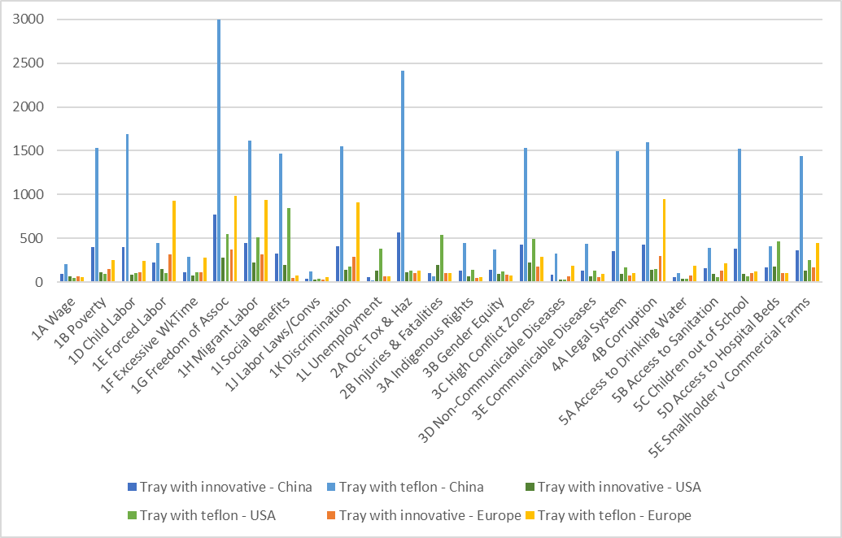
Figure S1. Subcategories weighting results for the comparison between the 5y life cycle of the tray incorporating the innovative anti-stick coating and the benchmark, according to the three geographies.

Section 4. Comparison of the coatings – subcategory results
Figure 2 shows the results at the level of subcategories. The innovative coating is compared with the benchmark coating, again considering the three geographies for the sourcing of the raw materials. For both the innovative coating and the China-based material, the most impacted subcategories are freedom of association, occupational toxicity and hazard, and child labor.

Figure S2. Subcategories weighting results for the comparison of the innovative coating with the benchmark coating, according to the three scenarios.

Section 5. Focus: the innovative nano-enabled coating production – category results
Figure 3 shows the results of the assessment of the innovative anti-stick coating production. The most impacted categories are Health and Safety and Governance, reasoning with the results at the subcategories (i.e., high risk values for freedom of association, occupational toxicity and hazard, and high conflict zones).

Figure S3. Category weighting results for the innovative coating raw materials and resources.

Section 6. Survey to the suppliers
The survey was built starting from the results from the section 3.4.3 “Focus: the innovative nano-enabled coating production”. The questions were shared via email in the form of an online survey. As an exploratory effort, we decided to keep the number of questions below 10.The selection of subcategories to include in the survey followed the rationale of including higher risk subcategories in the material profile. The stepwise approach is the following:
- Pre-selection of SiC subcategories above 1 pt¹ (light orange)
- Pre-selection of Silicone subcategories above 0.2 pt (blue)
- Selection of subcategories relevant for both materials (violet and bold)
Subcategory | SiC (pt) | Silicone (pt)
1A Wage | 0,34609 | 0,059837
1B Poverty | 2,496192 | 0,139191
1D Child Labor | 3,818821 | 0,151048
1E Forced Labor | 0,679773 | 0,177245
1F Excessive WkTime | 0,455103 | 0,318639
1G Freedom of Assoc | 4,909932 | 0,212386
1H Migrant Labor | 2,624664 | 0,223913
1I Social Benefits | 2,417947 | 0,097481
1J Labor Laws/Convs | 0,174154 | 0,049545
1K Discrimination | 2,522247 | 0,174612
1L Unemployment | 0,028162 | 0,296574
2A Occ Tox & Haz | 3,983114 | 0,23368
2B Injuries & Fatalities | 0,079475 | 0,28637
3A Indigenous Rights | 0,732976 | 0,066208
3B Gender Equity | 0,57911 | 0,08592
3C High Conflict Zones | 2,512771 | 0,34358
3D Non-Communicable Diseases | 0,524856 | 0,041871
3E Communicable Diseases | 0,693883 | 0,085839
4A Legal System | 2,454339 | 0,091132
4B Corruption | 2,600675 | 0,243647
5A Access to Drinking Water | 0,156691 | 0,064167
5B Access to Sanitation | 0,597223 | 0,09014
5C Children out of School | 2,482492 | 0,098798
5D Access to Hospital Beds | 0,635619 | 0,13683
5E Smallholder v Commercial Farms | 2,358915 | 0,10054

Questions were then formulated starting from the UNEP Methodological Sheets for Subcategories in S-LCA². The survey shared with suppliers is reported below.

